Week 0

Yosys

1. $ sudo apt-get update
2. $ git clone <https://github.com/YosysHQ/yosys.git>
3. $ cd yosys
4. $ sudo apt install make
5. $ sudo apt-get install build-essential clang bison flex \

    libreadline-dev gawk tcl-dev libffi-dev git \

   graphviz xdot pkg-config python3 libboost-system-dev \

    libboost-python-dev libboost-filesystem-dev zlib1g-dev

1. $ make config-gcc
2. $ make
3. $ sudo make install

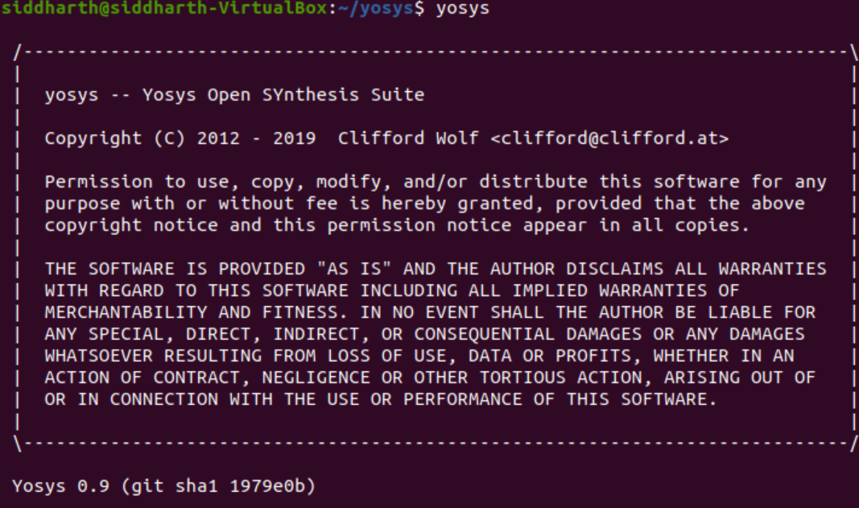

iVerilog

1) sudo apt-get update

2) sudo apt-get install iverilog

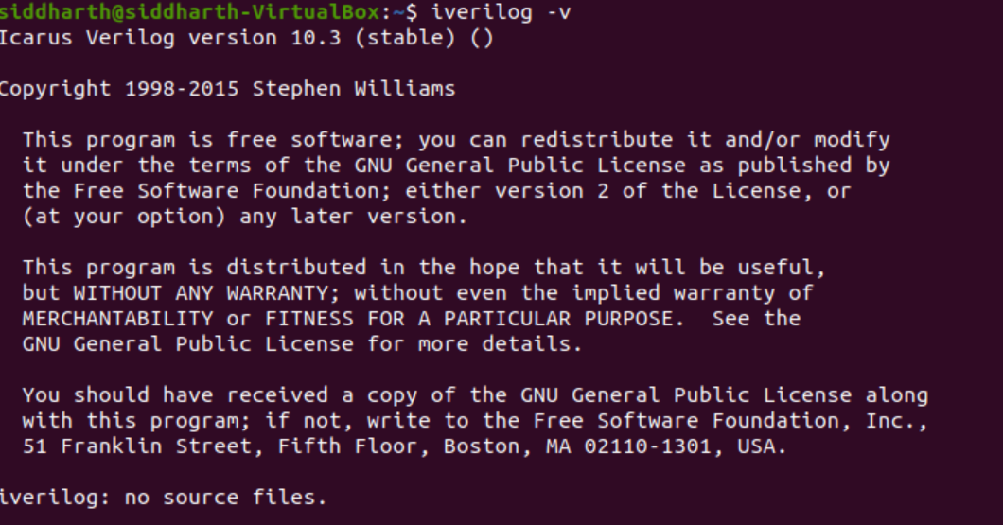

GTK Wave

1) sudo apt-get update

2) sudo apt install gtkwave

